Trinity Times

**5151 Lennon Road, Flint, MI 48507** **www.trinityunitedpc.org**

**810-720-5152 Sundays @ 10am**

**SUMMER 2023, VOLUME 7, ISSUE 2**

***ONE YEAR OF GRATITUDE***

It is hard to believe, but June 5th marked one year since our relationship as church and pastor began. I’ll never forget that joyous Pentecost morning, and the feeling I had as I prepared myself for worship that morning - a feeling of excitement and anticipation of the new things that God was beginning to work.

We have spent much of this past year getting to know one another. To me, there is no better foundation than building relationships with one another. When there are strong relationships, and a willingness to work on continuing to build such relationships, I feel that this opens all sorts of doors. Mostly, doors around communication and being able to discuss difficult and challenging topics that we might otherwise avoid.

Now, I do not claim to know what all will happen, or what is it that our church, and the larger church community will face this year and the years to come. Only God can know that. However, if the likes of social justice and creating a truly multicultural congregation are those things that TUPC feels are most important in making our congregation what it is, then we absolutely have our work cut out for us. I invite you to consider, how do we continue to draw the circle wide as it relates to multiculturalism and welcoming people of all ages? What about members of the LGBTQIA+ community? How do we continue to expand our welcome of people of other cultural backgrounds and heritages? These are all things we must consider if we want to be a truly multicultural congregation.

Friends, even though we might not know what lies ahead of us, we can give thanks that God has brought us together for such a time as this. If we trust in the guidance of the Holy Spirit and work to continue to build up the foundations of community that we have laid, I have no doubt that we can meet whatever hard conversations and challenges that come our way, head on. And as we lean on God and trust God’s guidance and wisdom, we will find that we are all better for it.

Let it be so, and may we have another excellent year of ministry together.

Live, Love, Laugh,

Rev. Kate Morritauk



***A PERSONAL NOTE FROM THE PASTOR:***

I am not often so public about my personal life, however, there is some news that I feel that I need to share with the TUPC community. Some may have already read a similar statement on my social media. However, I know that there are a number of people who do not use those platforms.

I wish that there was an easier way to say this. I know that I don’t really owe anyone an explanation, but one of the things I have strived for throughout my life, and especially my ministry is authenticity. And it is because of that authenticity, that I am making such a vulnerable post.

It is with great sadness that the Morritauks are going our separate ways. While Coulter and I separated close to the beginning of the year, we are now in the divorce process. Although things are not finalized, I will be going back to the last name of Morrison, and have already begun to do so for non-legally binding matters.

This decision has not been made lightly. But ultimately, after much discussion and therapy, Coulter and I cannot offer each other the lives that either of us want. Although we have shared many happy and magical moments, including our wedding day, life over the past 18 months has shown us that we ultimately want very different things.

I am grateful to Coulter for the love we’ve shared and all that we have learned during our relationship. We literally weathered the worst of the Covid-19 pandemic together, and Coulter has seen me at my best and my worst. Ultimately, it is my prayer that we both find the love and wellness that we need to be our best, happiest selves. We both deserve that.

People have been asking how they can help or if there is anything that they can do. Please pray for both myself and for Coulter. This whole process has obviously thrown both of our lives into chaos, and most days I know I’m feeling like I’m doing my best to simply keep my head above the waves of the grief and sadness. But I am also doing my best to reach out for help when I need it, with many thanks to my therapists and counselor. I am doing what I can to best care for myself and offer myself the grace and love that we all deserve when we go through life-shattering events. I’d also appreciate not having to answer any questions or being asked to speak more about what brought everything about at this time.

I want to express my personal thanks to the Session of TUPC, for their nurture and care over these past months. There was initially some concern for my safety, and the Session rose to the occasion to help me feel cared for and comforted as Coulter and I tried to come to some sort of understanding of how things would move forward.

Although there are still many steps to go through before all is finalized, I look forward to continuing this journey together with TUPC and am so grateful for your prayers. I have no doubt that God will bring us through this, and help us grow in the process.

***SAVE THE DATE***

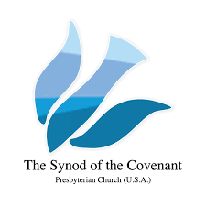

PW in the Synod of the Covenant

Gathering August 4 – 5, 2023

First Presbyterian Church Findlay, Ohio

Shining the Light on the PW Purpose



Matthew 5: 16

In the same way, let your light shine before others, that they may see your good deeds and glorify your Father in heaven.

Key Note Speaker

Cheri Harper – PW Mission Associate

Sacred Encounters 2023 – 2024 Bible Study

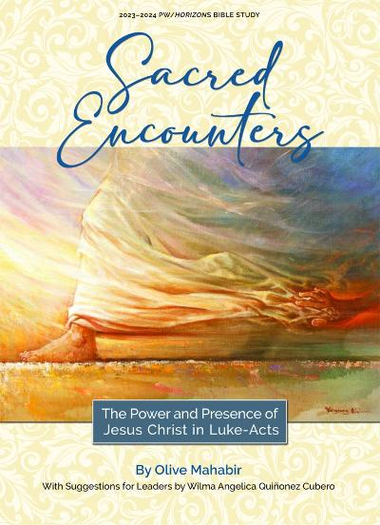

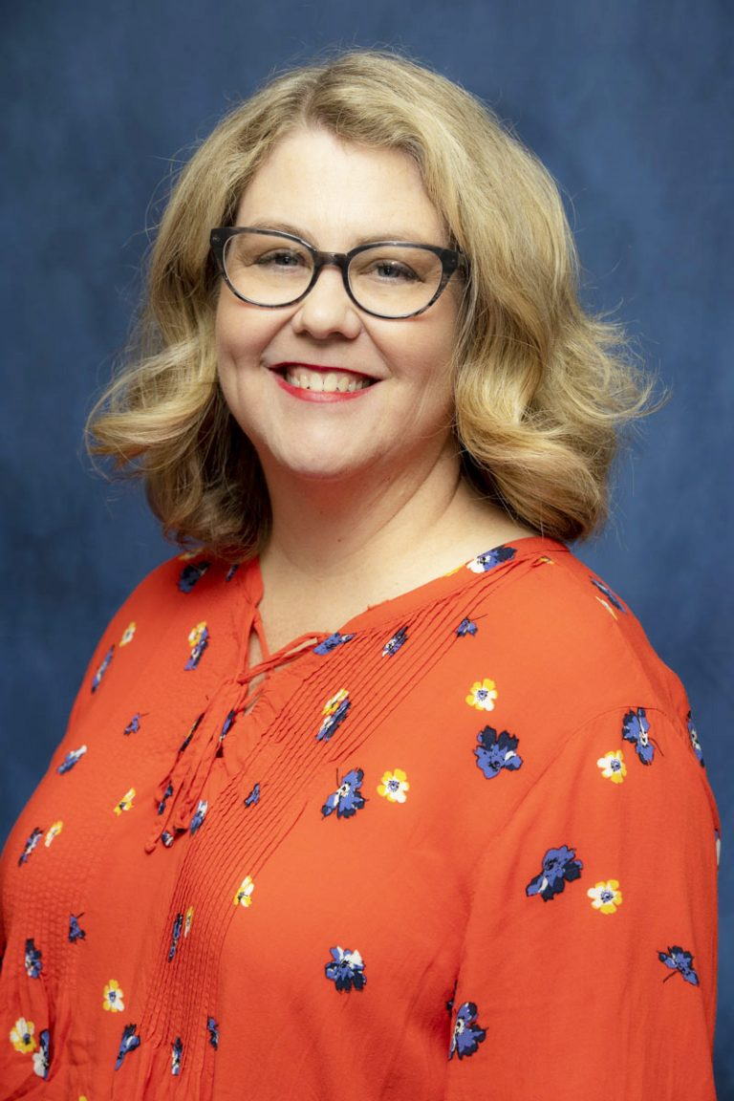

Registration - $50

***CHURCH PICNIC***

Our annual church picnic will be on August 13th at 10am at Elms Road Park. Come join us for food and fellowship!

It will be a potluck so bring a dish to pass. Hot dogs and buns will be provided. There are picnic tables but feel free to bring a chair if you want. There will be yard games, bingo and lots of fun! Hope to see you all there!!!

***2023-2024 CALENDARS***

Pre-orders are now being taken for the 2023-2024 Presbyterian Planning Calendars. Cost per calendar is $10.50 and all orders must be prepaid to the Presbytery Office by July 27th, 2023. There will be no cancellations after July 27th. Please reach out to Georgia McCall if you are interested in a calendar.

***CONGRATS GRADUATES!***

Congratulations to all the graduates we honored on graduation Sunday:

Griffin Henderson, Evan Auger, Bailey Macko, Amber Dixon, Eumorfia Ochodnicky, and Angelica Fowler!



***YOUR HELP NEEDED***

Your giving continues to be an important act of worship and witness. You can continue to faithfully give financially online at www.trinityunitedpc.org.

If you prefer to give by mail you can send checks to: Trinity United PC, 5151 Lennon Rd, Flint, MI 48507. Now is the time for our church family to serve others and reach out in love. Please continue to give so that the ministry of Trinity United may continue to thrive.

***PER CAPITA***

If you have not done so already, please make your 2023 per capita payment. The amount is $29.77 per member. Thank you to all of you who have already made your payment.  By contributing your portion of per capita, you have freed up dollars in our regular budget for the work of our congregation in this community.

***LINKS:***

Here are the links to stay connected with us online.

-Website: <http://www.trinityunitedpc.org/>

-Facebook: <https://www.facebook.com/TrinityUnitedPC.USA/>

-YouTube: <https://www.youtube.com/channel/UCjF2cBNiB8tQnV-pjsLEgGQ>

***REMEMBERING JIM OFFRINK***

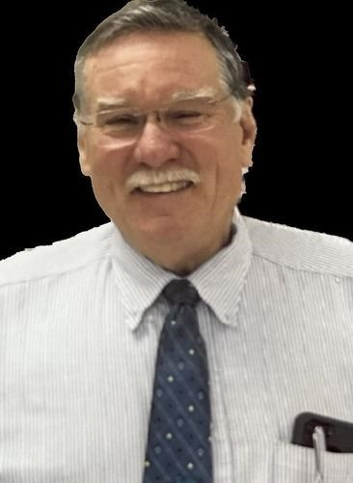

Rev. James F. Offrink of Fenton died May 2, 2023 at the age of 77.  
James Frederick Offrink, born to Frederick "Fred" Offrink and Bonnie Juanita Offrink, truly embraced the walk of Jesus and always demonstrated a servant's heart. Throughout his life Jim shared compassion with others and never judged another based on race, gender, status, or education. Jim was, in addition to being a Presbyterian Church (USA) Minister and Pastor, a volunteer Police Officer, Fire Fighter, Paramedic, Juvenile Officer, hazmat coordinator, deputy chief of the Elwood Fire Dept., Flint Police and Fire Chaplain, Stress Management Debriefing Specialist, and McLaren - Flint Staff Chaplain. Jim was proud of being part of the DMORT FEMA Team that served following Hurricane Katrina. Over the years, he served in a variety of areas and was especially good at providing loving care to those in difficult times. He was a gifted funeral officiant, overseeing a plethora of funerals in his 53 years of ordained ministry. He cared and showed God's love continually throughout his life. Jim was raised in Linden and was the oldest of five which included Geraldine (Greg) Stubb, Mark Offrink, Susan (Loren) Kelsey and Matthew (Dawn) Offrink. Jim played in the Linden High School marching band. He loved riding his horse and excelled in 4-H, where he met the love of his life, Sally Faussett, at that same 4-H fair. It was truly love at first sight. Jim professed his love on that first meeting and looked forward to their first date, their high school proms, coming back to see his dear Sally on breaks from Warren Wilson Junior College, and finally his daily Sally sightings while at Michigan State University where he received a BA in Religion and Sociology. After college Jim finally married Sally at First Presbyterian Church of Howell and together they set off on their way to San Anselmo Theological Seminary where Jim began his Master of Divinity degree. Every day together Jim and Sally were a forever team and each day of their 54-year marriage was a blessing from the Lord. Fixing their car across the country, Sally teaching while Jim received his education, and their own special life-excelling moments as they shared their interests and love on many adventures throughout their ministry career in Iowa, Colorado, Illinois, and Michigan. Jim served Plymouth Presbyterian Church, Iowa; First Presbyterian Church of Canon City, Colorado; Elwood Community Church, Illinois; Bethany Presbyterian Church of Flint, MI; Trinity United Presbyterian Church of Flint, MI; Yale Presbyterian Church, MI; and Heritage UCC Church of Davison, MI. Jim, an ordained Minister of Word and Sacrament, served as a hospital chaplain throughout his ministerial career, seeking to bring peace and hope to those on their most difficult days. While traversing five states, these newlyweds raised three wonderful children together: Laura Christine (Jeremy) Kelsey, Andy James Offrink, and Benjamin Thomas (Shelby) Offrink. Life was filled with new experiences, amazing love, and experiencing new grandchildren. Aaron Walker Kelsey, Walker Owen Offrink, Maeve Ann Offrink, and Hazel Jean Offrink all have a special bond with their Grandpa Jim. Throughout the years, Laura, Andy and Ben, enjoyed learning many life lessons from their father. From hunting and fishing, to woodworking and automotive skills, Jim shared his best knowledge with his children and grandchildren. Jim would drop everything for his children and always put himself out if someone needed him. This was experienced in every community he lived in, and his loving care was felt by all. Rev. Jim made a huge impact in the life of others and our world thanks him for serving well. We can hear God speaking to him now, "Well done, my good and faithful servant."

Reverend Jim had an impact on so many of us here at Trinity, especially those who were with him at Bethany. He will be remembered for his warmth, kindness and sense of humor. He is gone but not forgotten in our hearts. Prayers for his family, friends and church family who are grieving this loss.



***TUPC FINANCE REPORT***

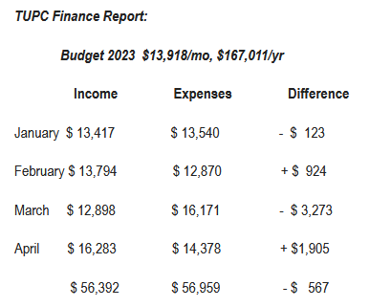

***SPECIAL OFFERINGS***

One Great Hour of Sharing

Hunger-Disaster-Development

February - April 2023

TUPC donated $275.00 to the Presbytery

***DOUBLEGOOD FUNDRAISER***

Our DoubleGood popcorn fundraiser was a success!

$3,718.50 Total Earned ($2,832.50 online sales + $886.00 cash donations)

110 DoubleGood Online Supporters

Top Sellers – Georgia McCall, Waldo Bronson, & Delphine Moore.

Thank you to everyone who participated in TUPC's popcorn fundraiser.  It was a success with lots of fun!!!

***DEACONS***

A special thanks to our deacons who are always working behind the scenes to do the Lord’s work, we see you and appreciate everything you do for our church and our community.

The deacons have updated their Support the Troops letters to twice a year now. They are doing cards for 4th of July and for Veterans Day.

The Soup Kitchen is every 3rd Friday and help is always needed. If you have time, please come out to help those in need.

A shout out to our current deacons:

Monica Wier, Eddie Barney, Levi Smith, Jerry Auger, Jeri Taylor, Kathy Henderson, Margaret Bausack and Alice Shirley.

***WEEKLY EVENTS***

Adult Sunday School - Every Sunday at 9:00am

Children's Sunday School - Every Sunday during Worship

Men's Bible Study - Every Wednesday at 11:00am

Sarah Circle - Every 2nd Wednesday of the month at 6:00pm

Sisters United in Christ Group - Every 3rd Wednesday of the month at 10:30am

Naomi Circle - Every 4th Thursday of the month at 10:30am

Game Day - Every 4th Tuesday at 1:00pm

***PRIDE MONTH***

June is PRIDE month and since we love and accept our LGBTQIA+ friends and siblings in Christ, here is some background on what Pride is and why it is important.

For those of you who are not familiar with the abbreviation, LGBTQIA+ stands for lesbian, gay, bisexual, transgender, queer or questioning, intersex, asexual and more. These terms describe a person’s gender identity or sexual orientation.

Pride month is an annual celebration of the contributions by the LGBTQIA+ community to society, culture and history across the world and is celebrated in June to commemorate its roots in the Stonewall Riots of June 1969.

The 1960s and the decades before were not loving and welcoming times for LGBT individuals, and were even illegal in some places including New York City.

On June 28th, 1969 the NYPD raided the Stonewall Inn, a bar in Greenwich Village because gays and lesbians were known to gather there. The confrontation escalated and six days of protest and riots happened which ended on July 2nd, 1969.

The Stonewall Riots moved the gay rights movement from an ignored fringe issue to front page news worldwide and was a critical step in the movement for gay rights.

On the one year anniversary of the riots was the first gay pride parade in New York and over the years events have spread to cities and towns all over the world.

These events range from fabulous celebrations, parades and events to political protests and memorials for all those lost to AIDS or homophobic violence. Gay Pride events, even amongst the celebration, are seen still as vital protests against repression in countries where rights are still being taken away and even in the United States you can see the oppression that is still being faced by those who protest these events and even threaten, attack and kill those at Pride events.

God calls us to love everyone and love our neighbors as ourselves. Love is all that matters and we should fight to stand up for hate in the world through the love that God gives us in our hearts. God loves all of us and we should all love each other and stand up for those being oppressed.



***JUNETEENTH***

Many people think that the Emancipation Proclamation in 1863 was the end of slavery in the United States, but that only freed slaves held in confederate states. It was until the passing of the 13th Amendment in 1865 that emancipation became a national policy.

The Emancipation Proclamation could not be implemented in those places still under confederate control. Finally on June 19th, 1865 some Union troops arrived in Galveston Bay, Texas and announced that the 250,000 enslaved black people in the state were free. This day became known as Juneteenth and it marks our country’s second independence day.

Juneteenth is the longest running African-American holiday in our history. Early celebrations used to be prohibited or limited to local celebrations but in the 1980s and 1990s it got more attention in the mainstream through media and awareness. In 1996 the first federal legislation to recognize Juneteenth Independence Day was introduced and campaigns continued for decades to get it declared a national holiday.

On June 17th, 2021 the Juneteenth National Independence Day Act was signed into law, making Juneteenth the first new federal holiday since Martin Luther King Jr. Day in 1986. Today it is a reminder of the past and ongoing fights for human rights and equality as well as a celebration of African American resilience and achievements.

***PRAYER LIST***

Prayers are needed for all members and friends of TUPC. We pray for the sick, the caregivers, the bereaved, mission workers, our leaders, our veterans, for racial peace and peace among nations.

We lift up those from the prayer chain:

Alice Shirley, Julie and Kevin, Bernice Williams, Griffin, Evan Auger, Mike, Tom Allen, Lorraine Brown, Eric Boler and family, Dorothy Payton, Stacie Harris, the Leache’s, Dewaine Mellen, the Payton family, Gwen Barney, Tyler Jones and Renta, Jim Offrink’s family, Mr. Cook, the family of Alfred Lee Cook, Gayle Kettler, Georgia McCall, Deirdre Scales, Carol Smith, the family of Thelma Teamer and all others who need our prayers.

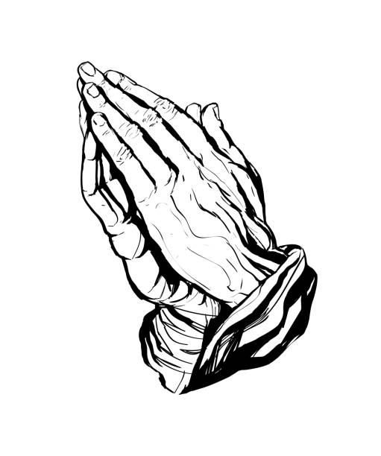

*Send a card, give a call say a prayer, or make a meal and let us continue to offer care and love to those who are grieving and struggling in one form or another.*

If you have a submission for the Fall issue of *Trinity Times*, please send your article or information to Alysha Fleming or Ryan Wier at [trinityunitedpccom@gmail.com](mailto:trinityunitedpccom@gmail.com) by no later than September 30th. Thank you.